# Homework: Web Services, SOA, SOAP, WSDL and REST

This document defines the homework assignments from [the "Web Services and Cloud" Course @ Software University](https://softuni.bg/courses/web-services-and-cloud/). Please submit as homework a single zip / rar / 7z archive holding the solutions (source code) of all below described problems.

## Distance Calculator SOAP Service

Create a **SOAP-based Web service** (**WCF Service Application** in Visual Studio) for calculating distances between points in the plane.

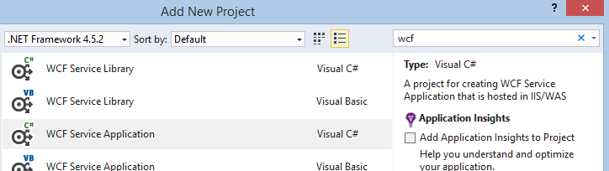

It should expose an endpoint "CalcDistance" taking two parameters: startPoint(x, y) and endPoint(x, y). Use integer coordinates.

It should return as a result a single **floating-point number**.

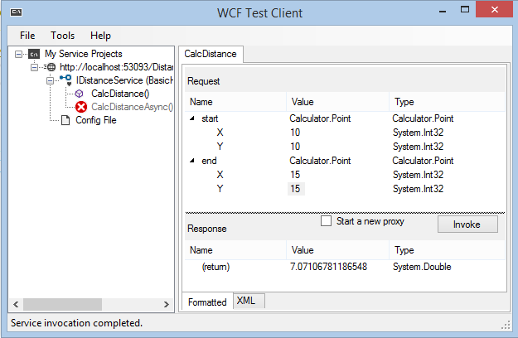

The service should be consumable through the **WCF Test Client** (started with **CTRL+F5**).

## Distance Calculator Client

Write a C# client to invoke the Distance calculator SOAP service. Use a Console application. Add a reference to the service by entering its **URI** (you can get it from the WCF test client interface).

|  |  |
| --- | --- |
|  |  |
|  | |

Create a **new instance** of the service. Invoke the desired **method** and **print the results** on the console. Make sure you **dispose the service** at the end.

## Distance Calculator REST Service

Write a **RESTful Web service** to calculate distance between points in the plane. It should take two points as input (integer coordinates x and y) and return a JSON as a result (a single **floating-point number**).

Create an **ASP.NET Web Application** (**Web API** type). The endpoint should receive the parameters as query string **key-value separated pairs**. The service should be accessible with Postman and should yield the following result:

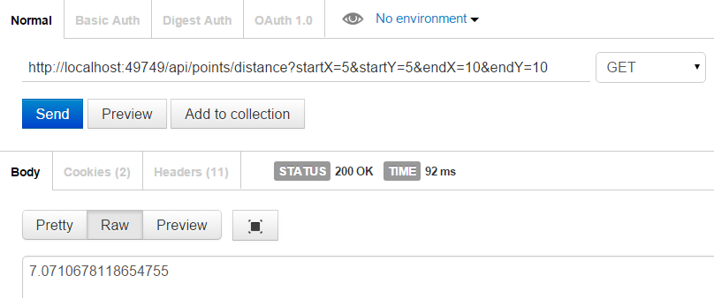

## Distance Calculator REST Client

Write a C# client to **programmatically** **invoke** the Distance calculator **REST service**. Use external REST library like **RestSharp** (<http://restsharp.org>) or the built-in .NET classes like WebClient, HttpClient or HttpWebRequest.